NATIONAL REMEMBRANCE DAY
May 2nd 2012
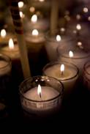

National Domestic Violence Remembrance Day is observed on Wednesday 2nd May.

It is a time we reflect on the women, children and families who have been killed in the context of domestic violence.

There are hundreds of candle lightening events which will be held across the country. They are held at the same time 6pm.

It is a powerful act of solidarity for everyone to come together against the horror of domestic violence deaths. It is also a place where families of victims can connect to others

There are many questions that are asked at this time and a common question is- how many women and children have been killed as a result of domestic violence?

We don’t know. The information is not readily available- and it should be. This information should be freely and openly accessible….our community needs to be aware that domestic violence is serious and can result in fatality. As a community we should know.

We call for a national awareness campaign highlighting how many women and children are killed as a result of domestic violence

We ask you to light a candle in your workplace to remember the women and children killed as a result of domestic violence.

We ask you to pass on this candles e-mail through your networks to encourage others to light a candle.

We ask you to pass on this candles e-mail to your local MP.

Remembering women, children and families killed as a result of domestic violence

Domestic Violence Death Reviews
The national campaign for each state in Australia aims to establish an independent Domestic Violence Death Review process in each state. We believe the only acceptable model is an evidence based best practice model.
This best practice model needs to be consistent across all states and territories and should be established in every Australian state.

In NSW in 2011 women and children were killed as a result of domestic violence.
We don’t know how many because this information is not reported publicly. As a community and public interest issue, it should be.

In SA from July 2008 to April 2012, as far as we know, there were 17 fatal events against a background of domestic violence.

15 dead women + 2 dead children + 9 dead men + 1 stabbed woman + 1 stabbed baby = 24 dead people + 2 seriously injured in 3 years and 4 months.

All the 15 dead women and children and the two injured were killed or injured by men. Seven of the dead men killed themselves; another was shot dead by Police and one died after being set alight by his wife after years of his domestic abuse of her.

We are told the number of deaths on the road due to car accidents, deaths on building sites, soldiers killed
in conflicts yet…

there is no national awareness campaign highlighting how many women and children are killed as a result of domestic violence

As a community ……………………………we should be told

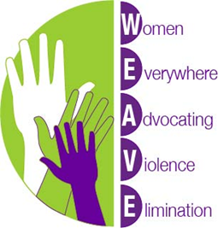

http://weaveinc.org.au

